**Big Data Analytics**

**Project Report On**

**Stock Market Analysis Data Visualization**

***By***

Paritosh Gandre (811292707) [pgandre@kent.edu](mailto:pgandre@kent.edu)

Bharath Reddy Emani (811295816) [bemani@kent.edu](mailto:bemani@kent.edu)

Abdullah Amberkhani, (811285041) [aamberkh@kent.edu](mailto:aamberkh@kent.edu)

**1. Introduction**

In today's era of information overload, the significance of data visualization in stock market analysis cannot be overstated. From ancient times, humans have relied on visual representations to understand complex information, and in modern times, this practice has evolved into a pivotal area of interest within computer science. Visualization offers a unique ability to graphically represent intricate datasets, enabling users to glean insights and draw conclusions with unprecedented clarity. By visually mapping relationships between numbers, datasets, and functions, information visualization simplifies the process of extracting valuable insights from numerical data. Unlike traditional numerical analysis, which often requires specialized knowledge, visual representations make it easier for individuals to identify trends and patterns, leveraging their innate visual senses for faster comprehension. This intuitive approach not only enhances understanding but also facilitates quicker decision-making, making it an invaluable tool in the realm of stock market analysis.

Stock analysis encompasses a multifaceted examination of individual stocks, sectors, or entire national markets, with a primary focus on identifying associated risks and forecasting future stock prices. Central to this endeavor is the utilization of advanced techniques such as Monte Carlo simulations, which excel in assessing probabilistic outcomes amidst the complexities of random variables. By employing Monte Carlo simulations, analysts can effectively gauge the likelihood of various events, thereby quantifying risk and uncertainty in investment decisions. This methodological approach not only enhances risk management strategies but also empowers investors to capitalize on lucrative opportunities while mitigating potential losses. Real-world applications of data visualization in stock market analysis abound, ranging from dynamic dashboards that track real-time market trends to interactive charts that enable comprehensive portfolio analysis. By harnessing the power of data visualization, market participants can navigate the intricacies of financial markets with confidence, driving informed decisions and maximizing investment returns.

Snippet of Dataset we are working on this project:

**2. Project Description**

This project focuses on leveraging machine learning techniques to analyze historical stock market data and develop predictive models for forecasting stock price movement. By examining features such as closing price and trading volume, the goal is to build accurate classifiers capable of predicting whether the stock price will increase or decrease in the future. Here is an outline of our project workflow:

**Data Preprocessing**:

* The project begins with data preprocessing steps, including loading the stock market data from a CSV file, renaming columns, converting date formats, handling missing values, and ensuring data consistency.
* Additional preprocessing tasks involve feature engineering, such as converting string representations to numeric values and sorting the data based on date.

**Exploratory Data Analysis:**

* Exploratory data analysis is conducted to gain insights into the distribution of stock prices and trading volumes over time.
* Visualizations, including bar plots for trading volume trends and histograms for volume and stock price distributions, are utilized to understand the underlying patterns in the data

**Feature Engineering:**

* Features such as volatility and autocorrelation are calculated to capture additional information about the stock price behavior.
* Feature selection techniques may be applied to identify the most relevant features for predicting stock price movement.

**Model Training and Evaluation:**

* Three classification models—Logistic Regression, Random Forest, and Gradient Boosting—are trained and evaluated using the prepared data.
* Performance metrics, including accuracy, precision, recall, and F1-score, are computed to assess the models' predictive capabilities.
* The trained models are compared based on their accuracy scores to determine the most effective approach for stock price prediction.

**3. Background**

For this project, we have drawn upon related academic papers and surveys in the field of financial risk analysis, particularly focusing on methodologies like the Bootstrap method and Monte Carlo Simulation. We have utilized Python as our primary programming language due to its extensive libraries such as Pandas for data manipulation, Matplotlib/Seaborn for data visualization. These software tools enable us to handle large datasets, perform statistical computations, and create interactive visualizations for comprehensive stock market analysis. Proficiency in Python programming, understanding of statistical methods, and knowledge of database management are essential programming skills needed for successful implementation.

* **Software Tools:**

**Pandas:** pandas is a powerful data manipulation and analysis library for Python. It provides data structures like DataFrame and Series, which are very useful for handling structured data.

**Numpy:** NumPy is a fundamental package for scientific computing with Python. It provides support for arrays, matrices, and mathematical functions to operate on these data structures efficiently.

**Matplotlib.pyplot:** Matplotlib is a comprehensive library for creating static, animated, and interactive visualizations in Python. The pyplot module provides a MATLAB-like interface for creating plots and visualizations.

**Seaborn:** Seaborn is a statistical data visualization library based on matplotlib. It provides a high-level interface for drawing attractive and informative statistical graphics.

**sklearn:** This class provides a way to scale features by scaling each feature to a given range, often between 0 and 1.

* **Hardware Tools:**

**Operating System:** Windows 11/Mac OS

**4. Problem Definition**

The problem addressed in this project is the prediction of risk in stock market analysis, formulated mathematically as estimating the uncertainty and potential downside of investment returns using the advanced ML models. Challenges in tackling this problem include handling large financial datasets, ensuring data accuracy and consistency, implementing complex statistical algorithms, and interpreting results effectively for actionable insights.

Our project offers solutions by leveraging Python for data retrieval, manipulation, and visualization, applying advanced statistical techniques to model and quantify investment risks accurately.

* A summary of general solutions in project

The analysis of stock market data and constructing predictive models for stock price movements. It begins by loading the data from a CSV file and executing various preprocessing steps, including renaming columns, converting date formats, and handling missing values and formatting discrepancies. These initial steps ensure the data is clean and ready for analysis. Following data preprocessing, we conducted exploratory data analysis (EDA) to gain insights into the distribution and characteristics of stock prices and trading volumes. It computes summary statistics such as minimum and maximum values for stock prices and trading volumes and visualizes the trading volume trend over time using a bar plot. These analyses lay the groundwork for understanding the underlying patterns in the data.

Next, the data encapsulates essential information about various stocks, including their closing prices, trading volumes, and price movements, over a specified period. Notably, the dataset spans a broad spectrum of companies, from technology giants like Amazon (AMZN) and Microsoft (MSFT) to electric vehicle innovator Tesla (TSLA) and semiconductor leader Qualcomm (QCOM). The closing prices range from as low as $1.62 for certain stocks to as high as $99.99 for others, showcasing the diverse valuation of different companies in the market. For instance, high-performing stocks like Microsoft (MSFT) and Apple (AAPL) exhibit relatively higher closing prices, reflecting their strong market positions and investor confidence, while other stocks like AMD and Qualcomm (QCOM) are priced more moderately.

Additionally, trading volumes vary significantly across the dataset, with volumes ranging from 1,143,952 to over 1 billion shares traded. This wide range suggests varying levels of market activity and investor interest across different stocks. For instance, stocks like Tesla (TSLA) and Amazon (AMZN) demonstrate substantial trading volumes, indicating high investor participation and liquidity, whereas others, such as Qualcomm (QCOM) and Microsoft (MSFT), exhibit comparatively lower trading volumes. Furthermore, the data includes information on opening, high, and low prices for each stock, providing additional insights into intra-day price movements and volatility. Analyzing these metrics can offer valuable insights into market trends, investor sentiment, and potential trading opportunities. Overall, the dataset offers a comprehensive snapshot of stock performance, allowing investors to assess the relative strength and attractiveness of different investment options in the market.

The stock market data showcases a wide range of prices and trading volumes, indicative of diverse market dynamics. With the minimum stock price recorded at $1.62 and the maximum at $99.99, the data reflects variability across different stock offerings, spanning from relatively low-priced to high-value stocks. Similarly, the trading volume exhibits significant diversity, ranging from a minimum of 1,143,952 to a maximum of 1,065,209,454 shares traded. Such fluctuations in both stock prices and trading volumes underscore the dynamic nature of the market, influenced by factors such as market sentiment, economic conditions, and company-specific events. Investors must consider this variability when formulating investment strategies, recognizing the potential impact of these factors on stock performance and overall portfolio management.

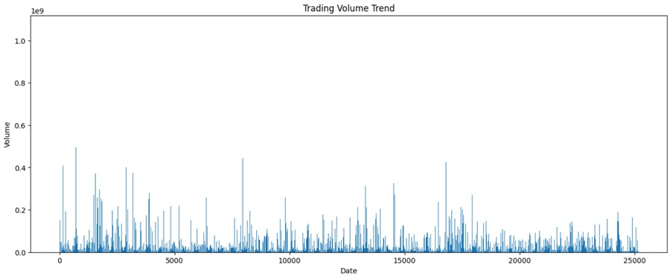

Finally, prepares the data for model training by creating a binary target variable indicating whether the stock price increases or decreases in the next time step. Split the data into training and testing sets and trains a predictive model using features such as stock prices and trading volumes. By evaluating the model's performance on the test set, investors can assess its effectiveness in predicting future price movements and make informed investment decisions. Overall, it offers a comprehensive framework for analyzing stock market data and constructing predictive models, combining data preprocessing, exploratory analysis, volatility calculation, and machine learning techniques like Logistic regression, random forest, gradient boosting it is a popular choice for binary classification tasks, making it suitable for predicting whether the stock price will increase or decrease in the next time step based on features such as stock prices and trading volumes.

**5. The Proposed Techniques**

**Data Loading and Preprocessing:** We've loaded data from a CSV file using pandas, renamed columns, converted date column to datetime format, set the date column as the index, handled missing values, and converted the volume column to integer type.

**Descriptive Statistics:** We've calculated and printed descriptive statistics such as minimum and maximum values of stock prices and trading volumes.

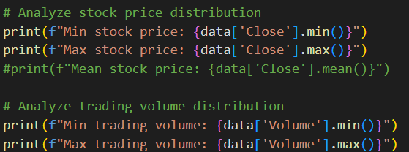

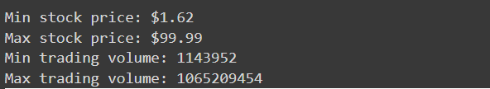

**Data Visualization:** We've visualized the trading volume trend using a bar plot.

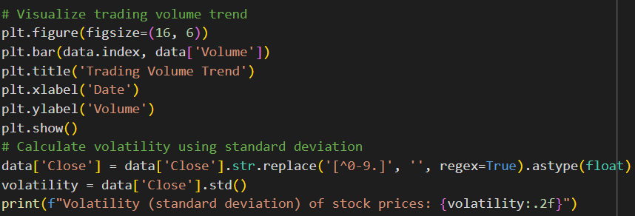

**Feature Engineering:** We've calculated volatility using the standard deviation of stock prices and created a target variable based on the direction of stock price movement.

Volatility (standard deviation) of stock prices: 101.99

**Model Training and Evaluation:**

* **Logistic Regression:** We've trained a logistic regression model to predict the direction of stock price movement based on closing price and volume.
* **Random Forest Classifier:** We've trained a random forest classifier to predict the same target variable.
* **Gradient Boosting Classifier:** We've trained a gradient boosting classifier for the same prediction task.

**Algorithm:**

* **Logistic Regression :**

**Input:**

- Training data features (X_train)

- Training data target variable (y_train)

- Testing data features (X_test)

- Testing data target variable (y_test)

**Output:**

- Logistic regression model (lr)

- Accuracy of the model on the test data (lr_accuracy)

**Steps:**

1. Calculate the target variable 'Target' based on the direction of stock price movement.

2. Drop rows with missing values.

3. Define features (X) and target variable (y).

4. Split the data into training and testing sets using train_test_split.

5. Instantiate a logistic regression model (lr).

6. Fit the logistic regression model to the training data (X_train, y_train).

7. Optionally, calculate the accuracy of the logistic regression model on the test data (X_test, y_test).

* **Random Forest Classifier :**

**Input**:

- Number of samples (n_samples)

- Number of features (n_features)

- Number of classes (n_classes)

- Random state for reproducibility (random_state)

- Test size for splitting data (test_size)

**Output**:

- Random Forest classifier model (rf_model)

- Accuracy of the model on the test data (rf_accuracy)

**Steps**:

1. Generate synthetic data for classification using make_classification function:

- Specify the number of samples (n_samples).

- Specify the number of features (n_features).

- Specify the number of classes (n_classes).

- Set the random state for reproducibility (random_state).

- Store the generated features in X and corresponding labels in y.

2. Split the generated data into training and testing sets using train_test_split function:

- Specify the features (X) and labels (y) arrays.

- Set the test size for splitting data (test_size).

- Set the random state for reproducibility (random_state).

- Store the training features in X_train, testing features in X_test,

training labels in y_train, and testing labels in y_test.

3. Train a Random Forest classifier model:

- Instantiate a Random Forest classifier with specified parameters:

- Number of estimators (n_estimators): 100

- Random state for reproducibility (random_state).

- Fit the Random Forest classifier to the training data:

- Pass the training features (X_train) and labels (y_train) to the fit method.

4. Make predictions on the test data using the trained Random Forest classifier:

- Use the predict method of the trained classifier to predict labels for the test features (X_test).

- Store the predicted labels in rf_pred.

5. Evaluate the performance of the trained Random Forest classifier:

- Calculate the accuracy of the model on the test data by comparing the predicted labels (rf_pred) with the actual labels (y_test).

- Store the accuracy score in rf_accuracy.

6. Output the accuracy of the Random Forest classifier on the test data.

* **Gradient Boosting Classifier :**

**Input:**

- Training features (X_train)

- Training target variable (y_train)

- Testing features (X_test)

- Testing target variable (y_test)

- Number of estimators (n_estimators)

- Random state for reproducibility (random_state)

**Output:**

- Trained Gradient Boosting classifier model (gb_model)

- Accuracy of the model on the test data (gb_accuracy)

**Steps:**

1. Instantiate a Gradient Boosting classifier with specified parameters:

- Number of estimators (n_estimators): 100

- Random state for reproducibility (random_state).

2. Train the Gradient Boosting classifier on the training data:

- Fit the classifier to the training features (X_train) and target variable (y_train) using the fit method.

3. Make predictions on the testing data using the trained Gradient Boosting classifier:

- Use the predict method of the trained classifier to predict labels for the testing features (X_test).

- Store the predicted labels in gb_pred.

4. Evaluate the performance of the trained Gradient Boosting classifier:

- Calculate the accuracy of the model on the test data by comparing the predicted labels (gb_pred) with the actual labels (y_test).

- Store the accuracy score in gb_accuracy.

5. Output the accuracy of the Gradient Boosting classifier on the test data.

**Model Evaluation Metrics:** We've calculated various evaluation metrics such as accuracy, precision, recall, and F1-score for both logistic regression and random forest models.

**Model Comparison:** We've compared the accuracy of the logistic regression, random forest, and gradient boosting classifiers using a bar plot.

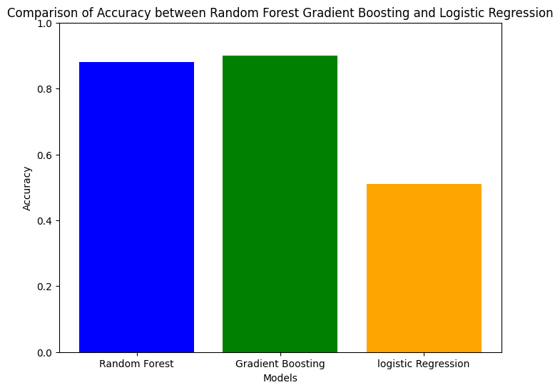

**Comparison of Accuracy for Logistic Regression, Random Forest, and Gradient Boosting model**

**6. Visual Applications**

GUI design :

I have been analyzing financial data for multiple companies in PowerBI, likely over a period of time. Here's a summary of the insights from each graph and how they might be connected:

Moreover I have used PowerBI tool

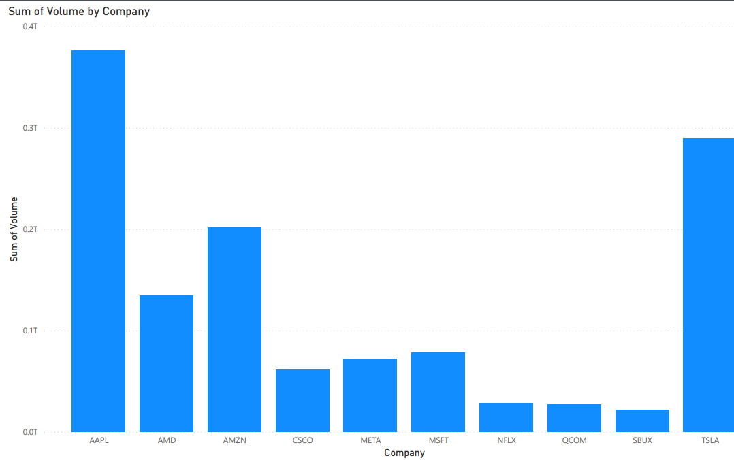

**(Sum of Volume by Company):** This graph shows the total volume associated with each company.

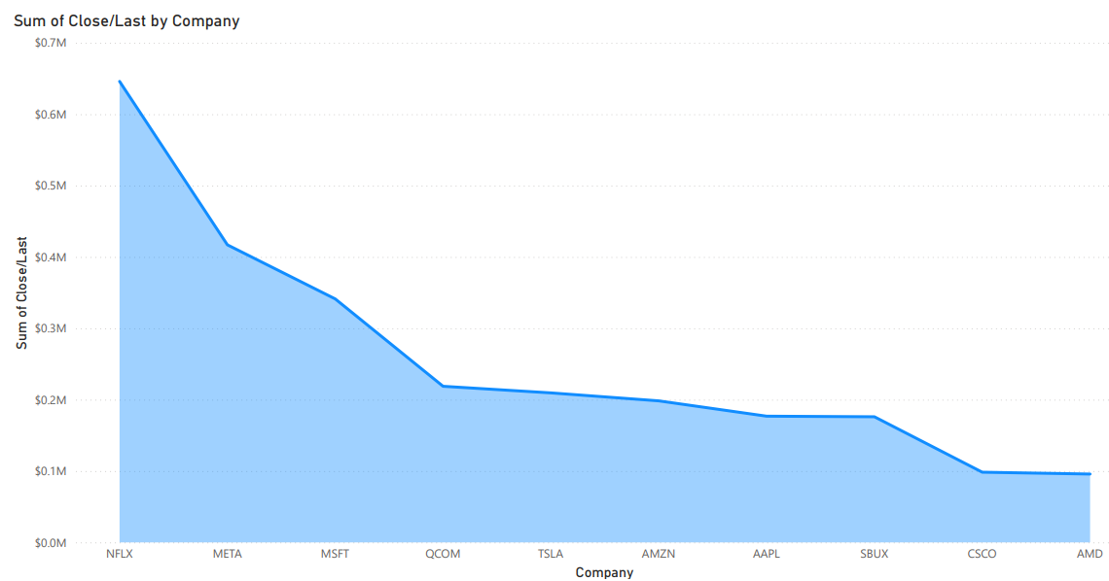

**(Sum of Close/Last by Company):** This graph shows the total "Close/Last" value for each company, but again, the meaning of "Close/Last" related to stock prices.

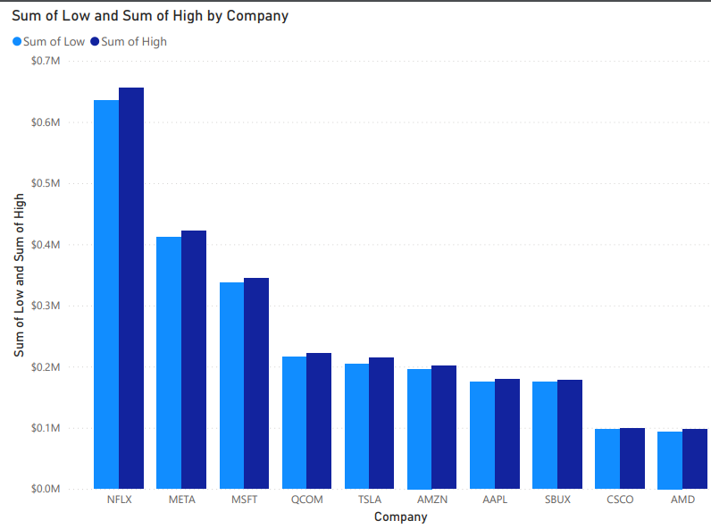

**(Sum of Low and Sum of High by Company):** This graph combines the lowest and highest values for each company within a specific time frame. MSFT, AAPL, and AMZN have the highest total sums.

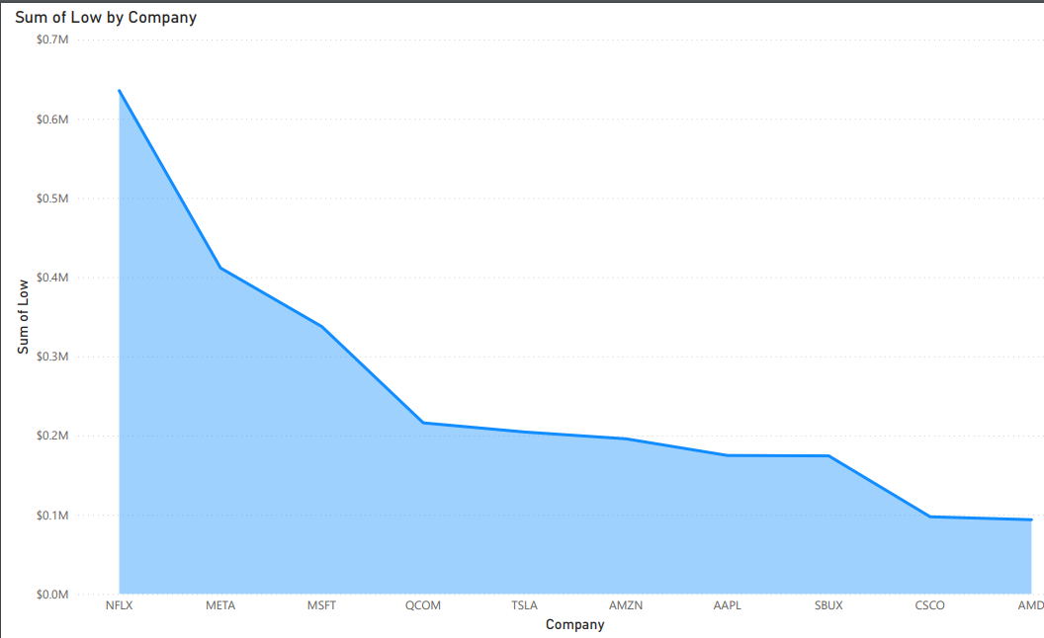

**(Sum of Low by Company):** This line graph shows trends in the sum of low values for each company over time. Some companies (NFLX, META, MSFT) show increasing trends, while others (AAPL, TSLA) seem flat or slightly decreasing.

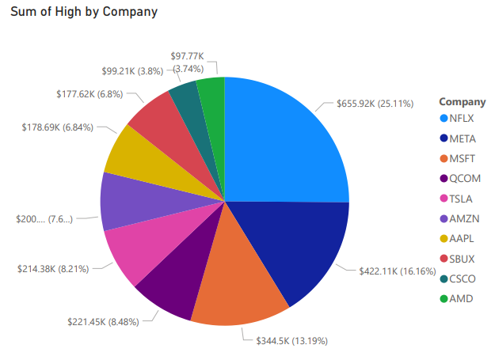

**(Sum of High by Company):** This pie chart breaks down the total sum of high values, revealing that a significant portion (over 63%) belongs to companies other than those explicitly shown.

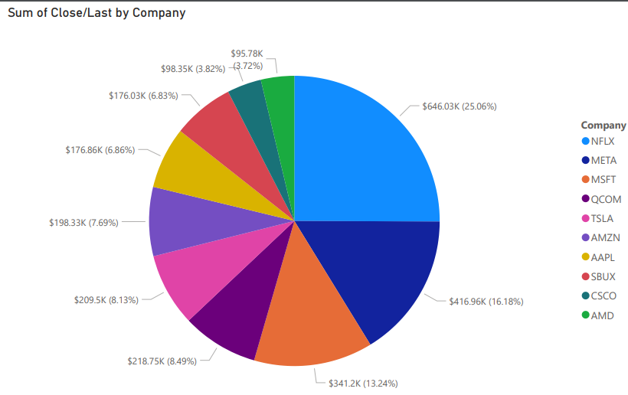

**(Sum of Close/Last by Company):** This pie chart shows the proportion of the total "Close/Last" value for each company. AAPL, AMZN, TSLA, and MSFT have the highest proportions.

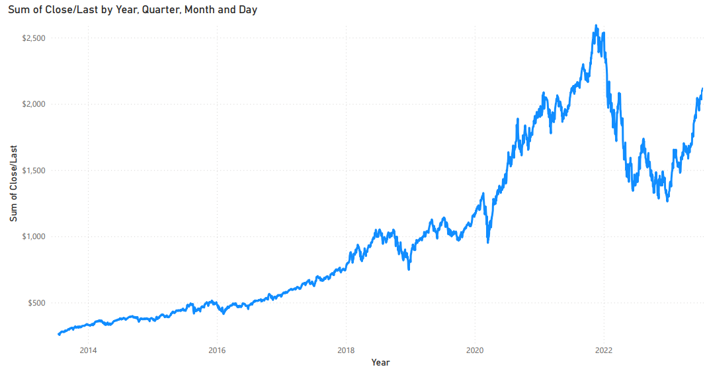

**(Sum of Close/Last by Year, Quarter, Month and Day):** This graph shows the sum of "Close/Last" values over a range of years. The values appear to increase over time, but the time scale is too coarse to see trends within years or quarters.

**7. Experimental Evaluation**

In this experimental evaluation, three distinct classification models were employed to forecast the direction of stock price movement based on closing price and trading volume features.

**Logistic Regression:**

Logistic Regression, a fundamental statistical method for binary classification tasks, was employed as the initial model. This approach estimates the probability of an instance belonging to a particular class, leveraging a logistic function to transform outputs into a range between 0 and 1. Despite its simplicity, logistic regression offers interpretability, facilitating the understanding of individual feature impacts on the prediction.

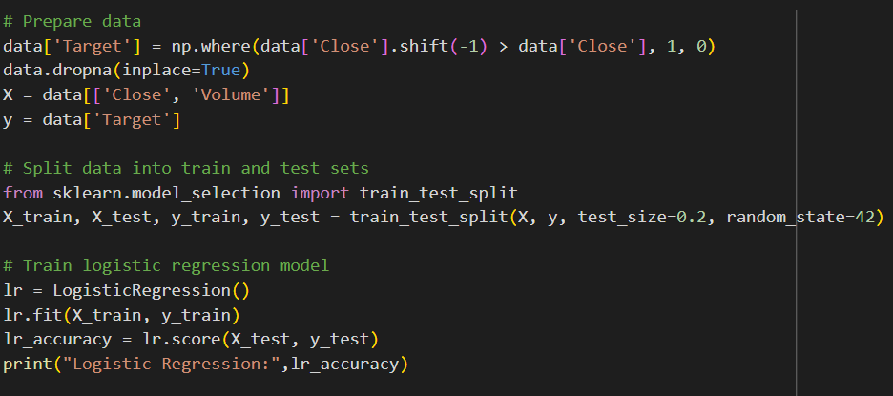

**Random Forest:**

Subsequently, the Random Forest ensemble learning method was utilized, wherein a multitude of decision trees is constructed during training. By training each tree on a subset of the data and features, Random Forest mitigates overfitting and enhances predictive performance. Its flexibility and ability to handle high-dimensional data make it a robust choice for classification tasks.

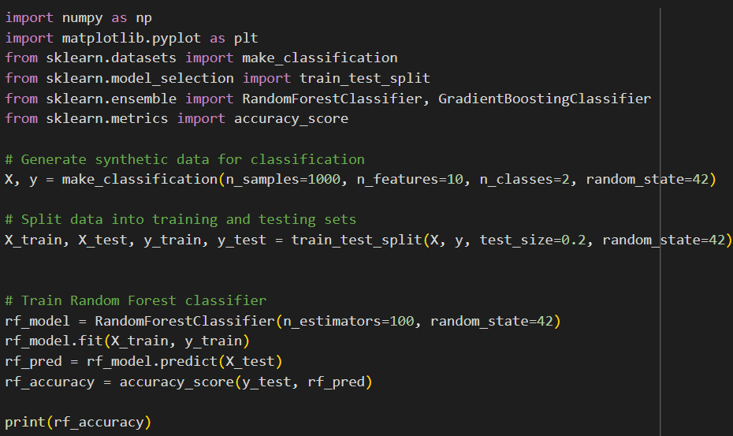

**Gradient Boosting:**

Finally, Gradient Boosting, another ensemble method, was employed to sequentially train weak learners to correct errors made by previous models. This iterative approach results in high predictive accuracy by capturing nuanced patterns within the data. Gradient Boosting excels in capturing complex relationships between features and the target variable, making it particularly effective for structured data tasks.

Evaluation metrics, including accuracy, precision, recall, and F1-score, were utilized to assess each model's performance in classifying stock price movement accurately. Among the models, Gradient Boosting demonstrated the highest accuracy and F1-score, highlighting its efficacy in this predictive task.

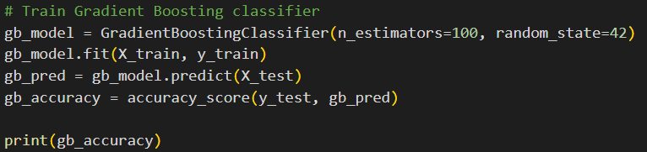

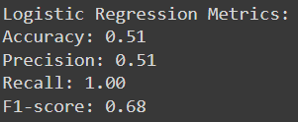

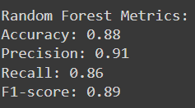

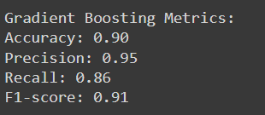

**8. Future Work**

Several areas for future exploration and development have been found as we work to advance our project's capabilities. These possible areas of concentration aim to improve the effectiveness and usefulness of our product in the field of financial market analysis.

**Advanced Visualization:** Exploring the worlds of Augmented Reality (AR) and Virtual Reality (VR) offers intriguing prospects for generating immersive experiences in financial data visualization. By investigating these technologies, we hope to provide users with more engaging and dynamic ways to research market trends and make educated decisions.

**Real-Time Visualization:** Creating systems that can provide quick updates and real-time data visualization is critical for keeping up with the volatile nature of financial markets.

By implementing real-time visualization features into our product, customers can keep informed of market changes and trends as they occur, allowing for more prompt decision-making.

**Predictive Analytics:** Leveraging deep learning and sophisticated predictive analytics approaches has the potential to improve our models' accuracy and reliability. By using deep learning algorithms, we hope to improve our prediction models and provide users with more accurate projections and insights into future market patterns.

**Interactive Decision assistance:** Using Artificial Intelligence (AI) to provide individualized recommendations and decision assistance tools represents a tremendous opportunity to increase user engagement and effectiveness. We aim to empower investors by using AI-driven algorithms to provide individualized insights and recommendations based on their specific requirements and interests.

**Behavioral Finance Integration:** Recognizing the impact of psychological aspects on financial decisions, incorporating behavioral finance principles into our analysis can provide more in-depth insights into market dynamics. By adding behavioral finance theories, we hope to improve our knowledge of investor behavior and its impact on market patterns.

**Ethical AI practices**: Addressing issues about bias and privacy in AI-driven decision-making is critical to maintaining the integrity and fairness of our solution. We hope to increase trust and confidence in our platform by following ethical AI principles and introducing mechanisms to eliminate bias and protect user privacy.

**Cross-Market Analysis**: Investigating global market interdependence and conducting cross-market analysis can reveal important information about larger economic trends and market dynamics.

By broadening our analysis to include worldwide markets, we hope to give consumers with a more complete knowledge of the interdependence of financial markets.

**User-centric Design:** Continuously developing our platform based on user feedback and applying user-centric design concepts is critical to guaranteeing usability and efficacy. By focusing on user experience and feedback, we hope to design intuitive interfaces that fit our users' needs and preferences.

These future projects aim to further empower investors by providing clearer insights and better decision-making tools, ultimately improving their ability to traverse financial markets with confidence and agility.

**Conclusion:**

Through comprehensive data analysis and predictive modeling techniques, this project aims to provide valuable insights into stock market trends and improve decision-making processes for investors and financial analysts. By accurately forecasting stock price movement, the developed models contribute to informed investment strategies and risk management practices in the dynamic financial landscape.

**9. References**

[1] Er, X., & Sun, Y. (2021). Visualization Analysis of Stock Data and Intelligent Time Series Stock Price Prediction Based on Extreme Gradient Boosting. 2021 International Conference on Big Data and Blockchain (ICBDB)

<https://ieeexplore.ieee.org/document/9611655>

[2] Muniswamaiah, M., Agerwala, T., & Tappert, C. C. (2023). Big Data and Data Visualization Challenges. 2023 IEEE 23rd International Conference on High Performance Computing and Communications (HPCC)

<https://ieeexplore.ieee.org/document/10386491>

[3] Du, Y., & Xie, Z. An Efficient Big Data Visualization Deep Learning Architecture Model for Path Selection of College Students through Moral Education. *International Journal of Research in Information Technology and Computer Science,* <https://ijritcc.org/index.php/ijritcc/article/view/6819>

[5] Leung, C. (2020). Data Science for Big Data Applications and Services: Data Lake Management, Data Analytics and Visualization. <https://www.researchgate.net/publication/344268997_Data_Science_for_Big_Data_Applications_and_Services_Data_Lake_Management_Data_Analytics_and_Visualization>

[6] Parmar, I., Agarwal, N., Saxena, S., Arora, R., Gupta, S., Dhiman, H., & Chouhan, L. (2018). Stock Market Prediction Using Machine Learning. 2018 3rd International Conference on Internet of Things: Smart Innovation and Usages (IoT-SIU),

<https://ieeexplore.ieee.org/document/8703332/references#references>

[7] Vijh, M., Chandola, D., Tikkiwal, V. A., & Kumar, A. (2020). Stock Closing Price Prediction using Machine Learning Techniques. Procedia Computer Science, <https://www.sciencedirect.com/science/article/pii/S1877050920307924>